DET TDC Sem 1 Examination 2010

Question/answer booklet

3CMAS MATHEMATICS: SPECIALIST

Section One (calculator-free)

Name:

Teacher:

Time allowed for this section
Section One
Reading time before commencing work: 5 minutes
Working time for paper: 50 minutes

Material required/recommended for this paper

To be provided by the supervisor
Question/answer booklet for Section One and a formula sheet (from Curriculum Council) which can be used for Section Two.

To be provided by the candidate
Section One:
Standard items: pens, pencils, pencil sharpener, highlighter, eraser, ruler

Important note to candidates
No other items may be taken into the examination room. It is your responsibility to ensure that you do not have any unauthorised notes or other items of a non-personal nature in the examination room. If you have any unauthorised material with you, hand it to the supervisor before reading any further.

Structure of this paper

Section | Number of questions available | Number of questions to be answered | Suggested working time  (minutes) | Marks  available
Section One:  Calculator-free | 8 | 8 | 50 | 40
Section Two:  Calculator-assumed | 9 | 9 | 100 | 80
 |  |  |  | 120

Instructions to candidates

- The rules for the conduct of Western Australian examinations are detailed in the Year 12 Information Handbook 2010. Sitting this examination implies that you agree to abide by these rules.

2. Answer the questions according to the following instructions.

Section One: Write answers in this Question/Answer Booklet. All questions should be answered.
Show all your working clearly. Your working should be in sufficient detail to allow your answers to be checked readily and for marks to be awarded for reasoning. Incorrect answers given without supporting reasoning cannot be allocated any marks. For any question or part question worth more than two marks, valid working or justification is required to receive full marks. If you repeat an answer to any question, ensure that you cancel the answer you do not wish to have marked.
It is recommended that you do not use pencil except in diagrams.

3. You must be careful to confine your responses to the specific questions asked and to follow any instructions that are specific to a particular question.

4. Spare pages are included at the end of this booklet. They can be used for planning your responses and/or as additional space if required to continue an answer.
  - Planning: If you use the spare pages for planning, indicate this clearly at the top of the page.
  - Continuing an answer: If you need to use the space to continue an answer, indicate in the original answer space where the answer is continued, i.e. give the page number. Fill in the number of the question(s) that you are continuing to answer at the top of the page.

MARK ALLOCATION AND RECORDS:

Section | Question | Marks | Awarded |  | Penalties
ONE | 1 | 7
ONE | 2 | 3 |  |  | Rounding (-1)
ONE | 3 | 7
ONE | 4 | 2 |  |  | Units (-1)
ONE | 5 | 7
ONE | 6 | 3 |  |  | Notation (-1)
ONE | 7 | 5
ONE | 8 | 6 |  |  | Missing ‘+c’ (-1)
ONE | Penalties | - 1/2/3/4
 | ONE | 40
 | TWO | 80
 | TOTAL | 120 |  |  | %
Section One (calculator-free) 40 marks

This section has eight (8) questions. Attempt all questions.

Suggested working time: 50 minutes

The following exact value table may be useful to answer questions in this examination.

 | 0⁰ | 30⁰ | 45⁰ | 60⁰ | 90⁰
Sin | 0 |  | 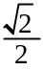 | 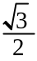 | 1
Cos | 1 |  |  |  | 0
Tan | 0 | 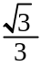 | 1 | 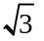 | undefined

Question 1: [7 marks – 1, 2, 1, 1, 1, 1]
Differentiate each of the following, simplifying fully:

a) 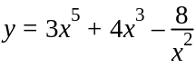 b) 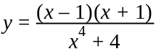

c) 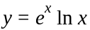 d) 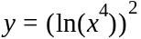

Question 1 cont…
e) 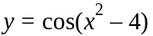 f) 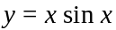

Question 2: [3 marks]
Determine 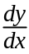 in terms of t for: 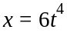, 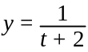.

[3]

Question 3: [7 marks – 1, 1, 1, 1, 1, 2]

Integrate the following:

a) 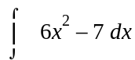 b) 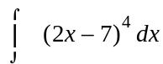

c) 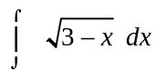 d) 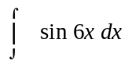

e) 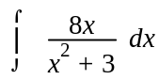 f) 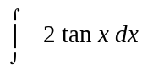

Question 4: [2 marks]
Determine a general solution to the differential equation: 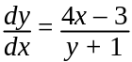. Simplify your solution fully.

[2]

Question 5: [7 marks]
Determine if: 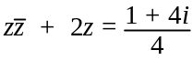.

[7]

Question 6: [3 marks]
If 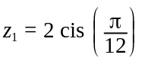 and 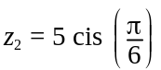, prove that: 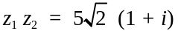

[3]

Question 7: [5 marks]
Determine the gradient of the curve defined by the parametric equations: 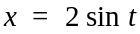 and 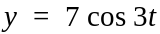, at the point where 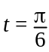.

[5]

Question 8: [6 marks]
Determine the coordinates of the points on the graph of: 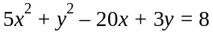, where the tangent to the curve is horizontal.

[6]

THIS PAGE HAS BEEN LEFT BLANK INTENTIONALLY

THIS PAGE HAS BEEN LEFT BLANK INTENTIONALLY

THIS PAGE HAS BEEN LEFT BLANK INTENTIONALLY


DET TDC Sem 1 Examination 2010

Question/answer booklet

3CMAS MATHEMATICS: SPECIALIST

Section Two (calculator-assumed)

Name:

Teacher:

Time allowed for this section
Section Two
Reading time before commencing work: 10 minutes
Working time for paper: 100 minutes

Material required/recommended for this paper

To be provided by the supervisor
Question/answer booklet for Section Two and a formula sheet (from Curriculum Council) which was provided with Section One.

To be provided by the candidate
Section Two:
Standard items: pens, pencils, pencil sharpener, highlighter, eraser, ruler
Special items: drawing instruments, templates, and up to three calculators, (CAS, graphic or scientific), which satisfy the conditions set by the Curriculum Council for this course. Up to two (2) A4 pages of notes (handwritten, photocopied or typed on both sides) that may be either personally or commercially produced. It must not be folded, have anything stuck to it or have correction fluid/tape on it.

Important note to candidates
No other items may be taken into the examination room. It is your responsibility to ensure that you do not have any unauthorised notes or other items of a non-personal nature in the examination room. If you have any unauthorised material with you, hand it to the supervisor before reading any further.

Structure of this paper

Section | Number of questions available | Number of questions to be answered | Suggested working time  (minutes) | Marks  available
Section One:  Calculator-free | 8 | 8 | 50 | 40
Section Two:  Calculator-assumed | 9 | 9 | 100 | 80
 |  |  |  | 120
Instructions to candidates

1. The rules for the conduct of Western Australian examinations are detailed in the Year 12 Information Handbook 2010. Sitting this examination implies that you agree to abide by these rules.

2. Answer the questions according to the following instructions.

Section Two: Write answers in this Question/Answer Booklet. All questions should be answered.
Show all your working clearly. Your working should be in sufficient detail to allow your answers to be checked readily and for marks to be awarded for reasoning. Incorrect answers given without supporting reasoning cannot be allocated any marks. For any question or part question worth more than two marks, valid working or justification is required to receive full marks. If you repeat an answer to any question, ensure that you cancel the answer you do not wish to have marked.
It is recommended that you do not use pencil except in diagrams.

3. You must be careful to confine your responses to the specific questions asked and to follow any instructions that are specific to a particular question.

4. Spare pages are included at the end of this booklet. They can be used for planning your responses and/or as additional space if required to continue an answer.
  - Planning: If you use the spare pages for planning, indicate this clearly at the top of the page.
  - Continuing an answer: If you need to use the space to continue an answer, indicate in the original answer space where the answer is continued, i.e. give the page number. Fill in the number of the question(s) that you are continuing to answer at the top of the page.

MARK ALLOCATION AND RECORDS:

Section | Question | Marks | Awarded |  | Penalties
TWO | 9 | 4
 | 10 | 6 |  |  | Rounding (-1)
 | 11 | 6
 | 12 | 9 |  |  | Units (-1)
 | 13 | 4
 | 14 | 4 |  |  | Notation (-1)
 | 15 | 11
 | 16 | 15 |  |  | Missing ‘+c’ (-1)
 | 17 | 7
 | 18 | 14
 | Penalties | - 1/2/3/4
 | TWO | 80

Section Two: Calculator – 80 marks

This section has eleven (11) questions. Attempt all questions.

Suggested working time: 100 minutes

Question 9: [4 marks]
Vectors and are as follows: 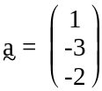 and 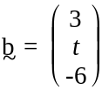. Determine the value of t if 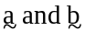 are:

a) Parallel to each other.

[1]

b) Perpendicular to each other.

[3]

Question 10: [6 marks]

Prove that the square of an integer NOT divisible by 5 leaves a remainder of 1 or 4 when divided by 5.

[6]

Question 11: [6 marks]
Determine the equations of A, B and C from the graph below:

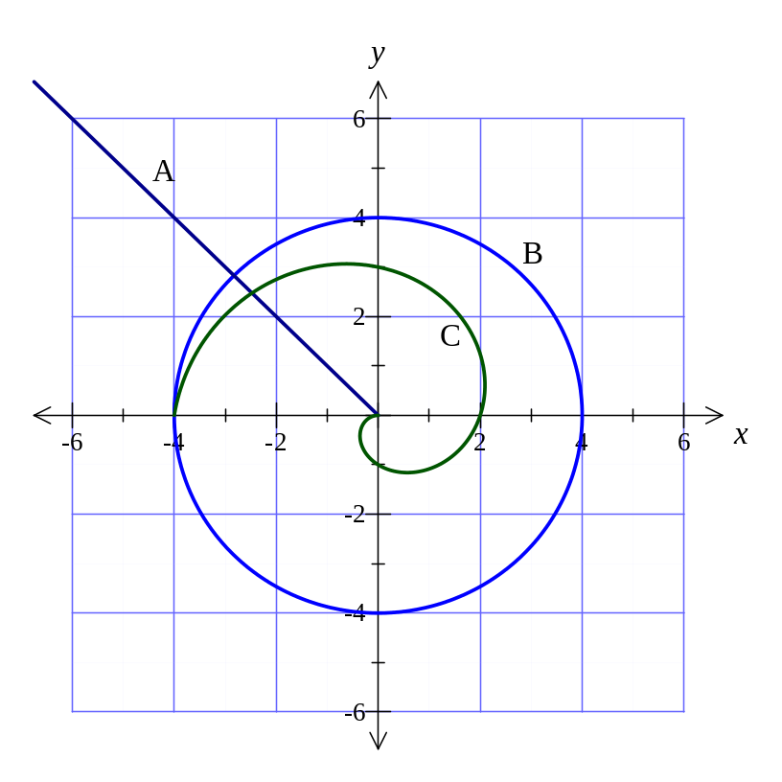

A =

B =

C =

[6]

Question 12: [9 marks]
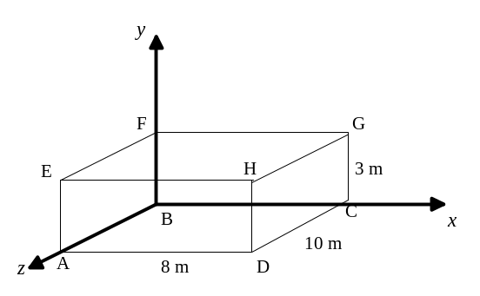
The diagram on the right shows a rectangular prism.

Determine:

a) 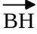

[1]

b) 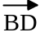

[1]

c) 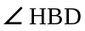 (in degrees, to 1 decimal place).

[3]

d) The acute angle between the skew lines BD and FE.

[4]

Question 13: [4 marks]

Prove the following:

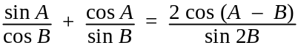.

[4]

Question 14: [4 marks]
Use calculus techniques to determine: 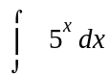.

[4]
Question 15: [11 marks]

ABCD is a parallelogram with points E and F such that 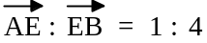 and 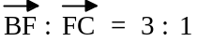. 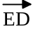 and 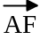 intersect each other at G. Let: 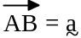 and 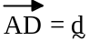.

a) Complete the diagram below with the information given above.
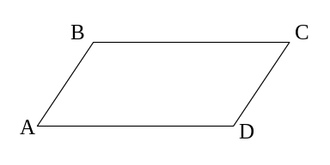

[2]

b) Determine the ratios in which and intersect each other, if the intersection point is at G.

[9]
Question 16: [15 marks]

If: a = <8, -6, 0> and b = <-2, 4, -1>, determine:

a) 2b – a

[1]

b) A vector in the same direction as a but equal in magnitude to b.

[3]

c) The acute angle that vector a makes with the y-axis.

[4]
Question 16 cont…

d) Point P lies on the line AB (from 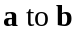) and it is known that: 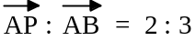. Determine the position vector of the point P.

[4]

e) If: c = <6, 5, -2> and d = <-10, -38, 11>, express d in the form: 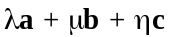, and hence determine 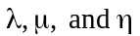. (Hint: Use the vectors a and b from the start of the question).

[3]

Question 17: [7 marks]

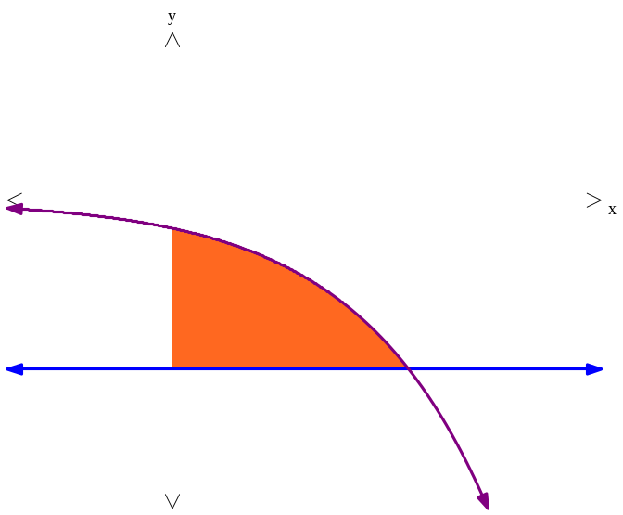
The graphs of 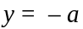 and 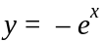 are shown below:
y = -a
y = -e^{x}

a) Write an expression for the shaded area (above), in the form: 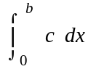.

[3]

b) Determine the values of a and b, if it is known that: 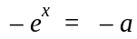, when
x = 1⋅7918.

[3]

c) Determine the area of the shaded region (to two decimal places).

[1]
Question 18: [14 marks]

The two countries Zedlandia and Xenutia are at war. Zedlandia (z) fired a ground to air missile in order to intercept a missile coming in from Xenutia (x). When z was launched, the position vectors (in metres), relative to the army base were:

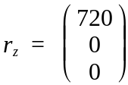 and 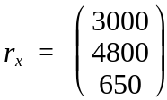.

Both z and x have constant velocities (m/s):

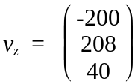 and 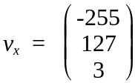.

a) Prove that the two missiles did not intercept.

[4]

Question 18 cont…

b) Determine by how much (distance and time) the two missiles missed each other (Note: Enough working must be shown in order to gain full marks).

[6]

Question 18 cont…

c) In order for the two missiles to collide, the z missile changed its flight plan after 15 seconds. The x continued on its path and then interception occurred 25 seconds later. Determine the constant velocity that z maintained in this second stage for interception to occur.

[5]

THIS PAGE HAS BEEN LEFT BLANK INTENTIONALLY

THIS PAGE HAS BEEN LEFT BLANK INTENTIONALLY

